Requirements/Design Specification

**Icons/Images on Pricing Page Navigate to an Empty Page**

**GH 530 – CR 13921**

Revision History

|  |  |  |  |
| --- | --- | --- | --- |
| **Date** | **Revision** | **Description** | **Author** |
| 4/28/2015 | 1.0 | Initial Version with Requirements | Roger Behm |
|  |  |  |  |
|  |  |  |  |
|  |  |  |  |
|  |  |  |  |

The information furnished herein by Republic Services Inc. is proprietary and confidential to Republic Services Inc. personnel and is not to be duplicated, published, or disclosed to any third party in whole or in part without permission from Republic Services, Inc.

© Copyright 2012, Republic Services Inc. - All rights reserved.

Table of contents

1 Business Requirements/Owner – Rich Simon 6

1.1 Purpose of the Design Specification 6

2 Assumptions 6

3 Design 6

4 InfoPro/TIBCO/BI Impacts 6

5 Report Changes 6

6 Appendix 6

# Business Requirements/Owner – Rich Simon

## Purpose of the Design Specification

Icons/Images on Pricing Page Line Item Grid Navigate to an Empty Page

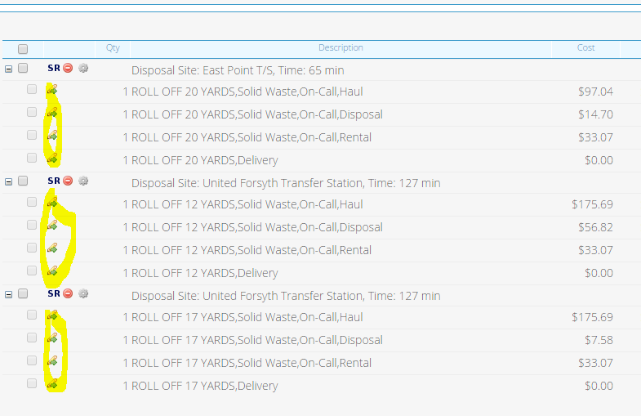

# Assumptions

NA

# Design

Should just be a style sheet change. Just need to identify the element and hide it within devrepublicservicesAlt.css

# InfoPro/TIBCO/BI Impacts

No new variable should be needed and no existing variables should be repurposed for any of the above changes.

# Report Changes

NA

# Appendix